**Ideation Phase**

**Empathize & Discover**

|  |  |
| --- | --- |
| Date | 22 September 2022 |
| Team ID | PNT2022TMID31901 |
| Project Name | Estimate The Crop Yield Using Data Analytics |
| Maximum Marks | 4 Marks |

**Empathy Map Canvas:**

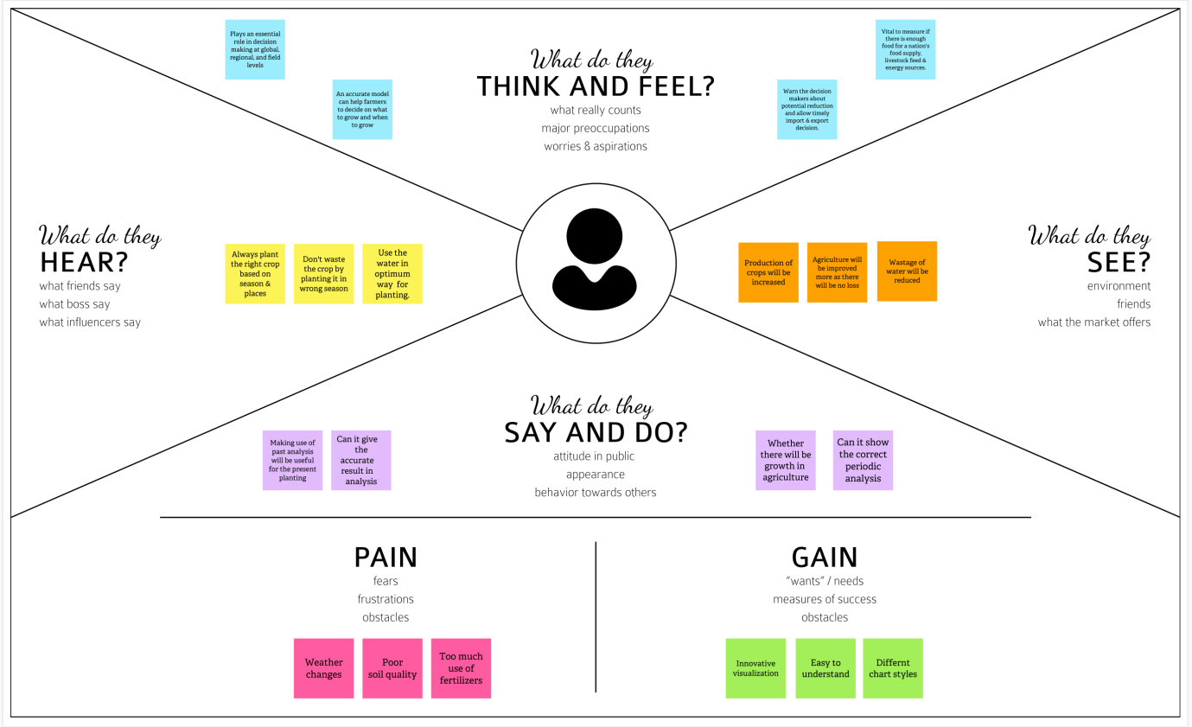

Reference: <https://app.mural.co/invitation/mural/naalaiyathiran1419/1663692920906?sender=u8d8fa718a17bacc9f02b4633&key=d1240fe4-2c69-4f16-b645-7c89dfe9be1e>